**Exercise 3:** PDF drawings of the list at each stage of insertion and list adjustment.

(Linked List in C)

Test 1:

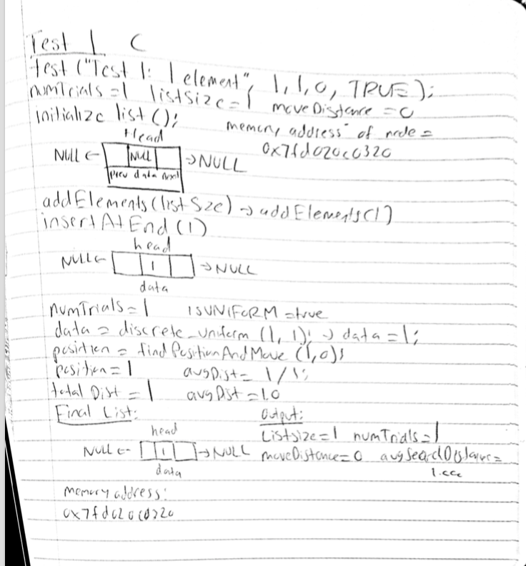

Test 2:

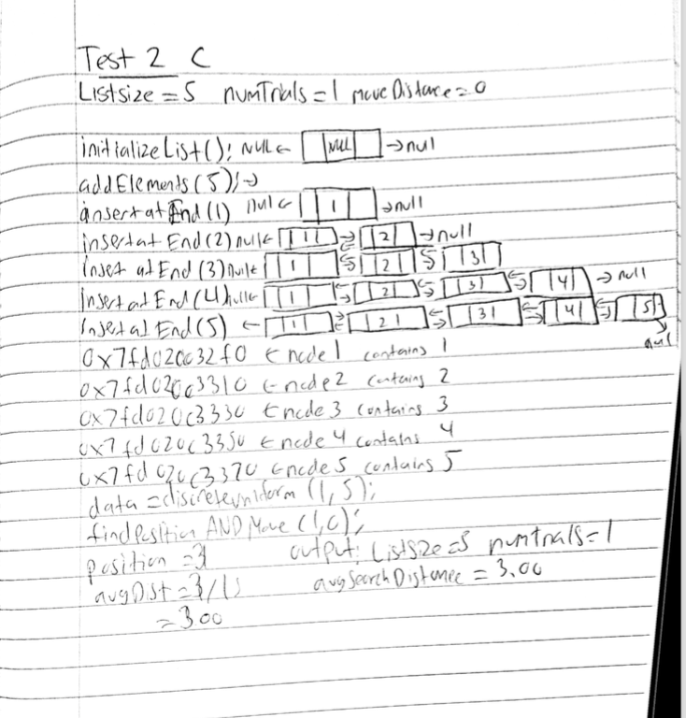

Test 3:

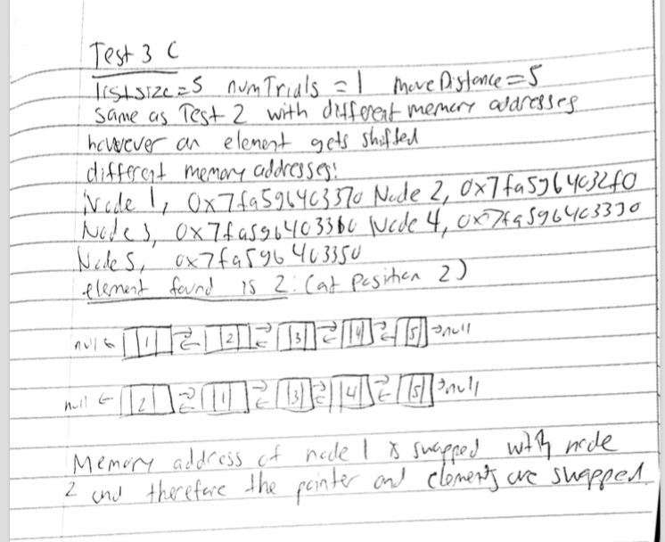

**Average search depth for a list of 10 elements using various values of moveDistance in the range of 1 to 10.**

Using a list with 10 elements, 10 as the number of trials and values of moveDistance from 1 to 7, here are the values for average search distance:

|  |  |
| --- | --- |
| Move Distance | Average Search Distance |
| 1 | 7.2 |
| 2 | 6.4 |
| 3 | 4.7 |
| 4 | 5.7 |
| 5 | 5.6 |
| 6 | 6.8 |
| 7 | 5.3 |

**Code to prove above:**

10 elements

Listsize=10 numTrials=10 moveDistance=1 avgSearchDistance=7.200000

10 elements

Listsize=10 numTrials=10 moveDistance=2 avgSearchDistance=6.400000

10 elements

Listsize=10 numTrials=10 moveDistance=3 avgSearchDistance=4.700000

10 elements

Listsize=10 numTrials=10 moveDistance=4 avgSearchDistance=5.700000

10 elements

Listsize=10 numTrials=10 moveDistance=5 avgSearchDistance=5.500000

10 elements

Listsize=10 numTrials=10 moveDistance=6 avgSearchDistance=6.800000

10 elements

Listsize=10 numTrials=10 moveDistance=7 avgSearchDistance=5.300000